## CART 360

## ETUDE TWO: Perceptron-P

## ZAHRA AHMADI

## STUDENT ID: 40047185

Links:

<https://a-zahra.github.io/Cart-360/Website/index.html>

<https://github.com/A-Zahra/Cart-360/tree/master/Etudes>

## A picture containing table Description automatically generatedPART ONE: Perceptron-P (Etude-Two Circuit to be Built)

In this circuit, resistors were the components that were preventing the lights to turn on. Through doing research on the color of the resistors' bands, I found out for the lights to turn on, the Ohm value of the resistors shouldn’t be more than the Ohm value of the LEDs, otherwise, the resistors resist against the entire current that the LEDs were supposed to receive, and thereby, the LEDs do not receive the required amount of current to turn on.

In this circuit, I used 200 Ω resistors instead of 220 Ω resistors so that I could turn on the LEDs.

## PART TWO: Perceptron-P (Etude-Two Alternate Circuit)

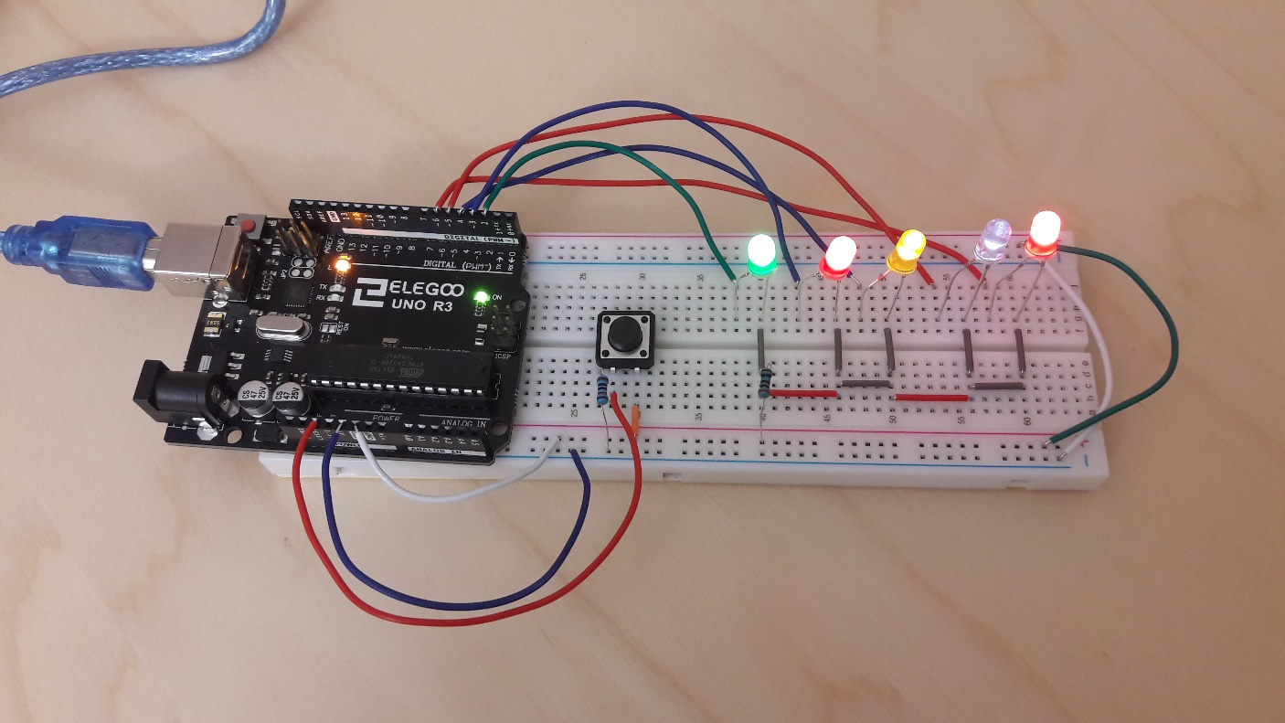

**Compare and contrast the Fritzing circuit illustrations for the Built Circuit to the Alternate Circuit.**

1. Determine the feature(s) that distinguish these two circuits – what makes them different? Why?

The main difference between the two circuits is that the Built Circuit is a Parallel Circuit while the Alternative Circuit is a Series Circuit. What is different between the two circuits is the way the current is being distributed among the LEDs.

While in the former, each LED has its own resistor to control the amount of current, in the latter, all LEDs share a common resistor to control the amount of the received current.

1. What is occurring with the V/ I / R in the area(s) that you have discerned as important?

In the Built Circuit which is a Parallel Circuit, the value of the voltage and the resistance of the resistors are constant for all LEDs. The amount of current that each LED is receiving is the same, as they all have the same amount of resistance against the current.

In the Alternative Circuit which is the Series Circuit, the current and the resistance value are constant for all LEDs. The voltage that all LEDs are experiencing is the same, as the current is controlled through one common resistor for all of the LEDs.

1. Which of the circuits presented would be more reliable circuit – Why?

Comparing the two circuits, I should say that the Built Circuit is more reliable for two reasons. First, If, one of the LEDs' connection is cut from the current, the rest of the LEDs will still work. Second, in the Built Circuit, the current distribution among all LEDs is equal and more reliable since each LED possesses its own resistor to control the receiving current. While in the Alternative circuit, only one resister is in charge to control the current for all LEDs which makes the whole circuit vulnerable against any possible mistake.

## PART THREE: Perceptron-P

**Explain, the purpose of the highlighted area contained within the red rectangle**

1. What does it do?

It resets the value of 2 to 6 pins to their initial values while the Arduino code is still running.

1. Why/How is the functionality implemented (electrically)?

It resets the amount of current which is being distributed among the LEDs to its initial value.